Created a repository and added files

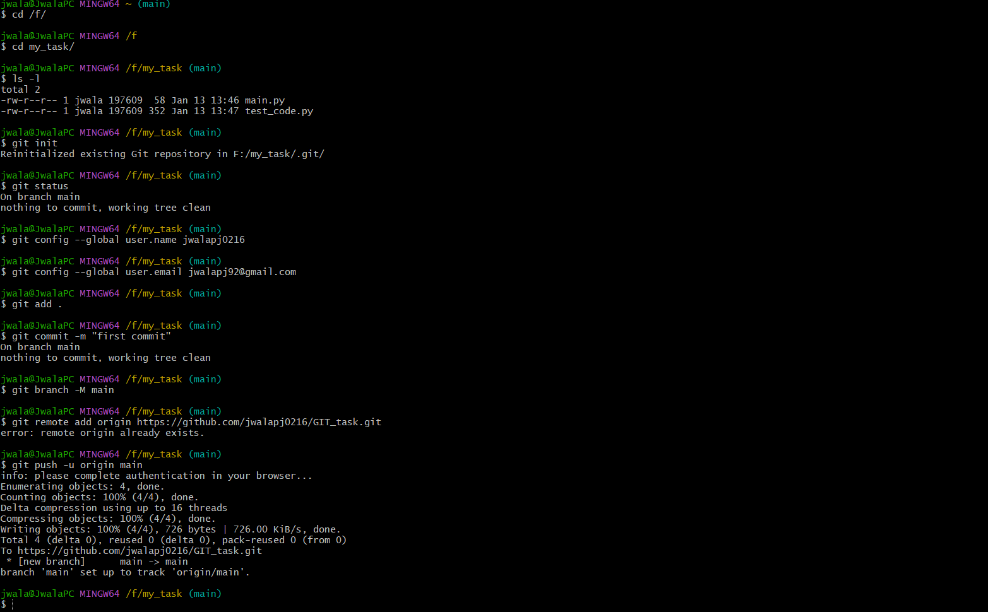

MERGE
Created a branch and added changes from the branch to a file ie to the test_code.py file and commit the changes with the comment. After that checkout to the main branch and merged the content to the main branch .
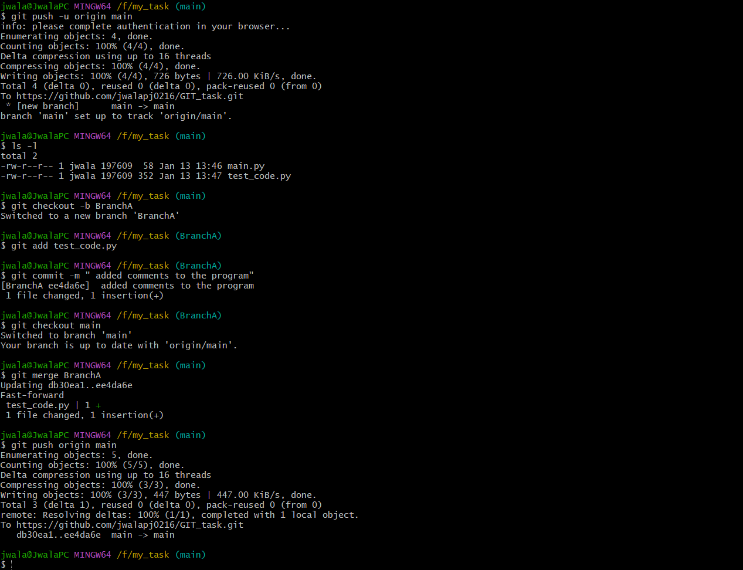

REBASE

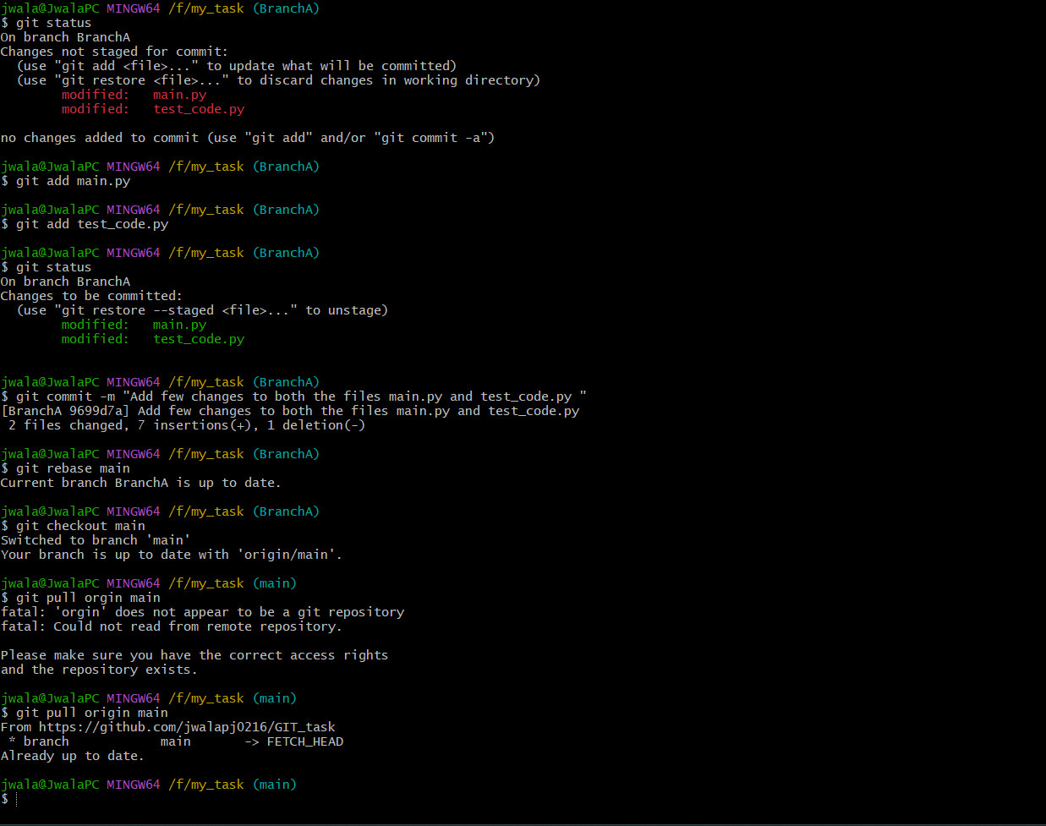

Stash
Stash modify or change the file but does not commit
